Monthly Performance Report – June 2025
Kestrel Ridge Wind Farm (75.6 MW)
David Chen · 09 July 2025 · KR-OPS-RPT-2025-06

1. Summary
Kestrel Ridge generated 10.2 GWh in June 2025, 8.1 % below the P50 budget of 11.1 GWh. Availability fell to 96.9 %, below the contract target of 97.0 %. Mean hub-height wind speed of 6.5 m/s was close to the long-term mean (6.7 m/s). Compared with June 2024 (11.5 GWh), output was down 1.3 GWh.
Annual service campaign continued: 7 turbines completed in June; average service downtime 31 h per turbine.

2. Production and key figures
KPI | June 2025 | Budget / target | YTD 2025 | YTD budget
Net generation (GWh) | 10.2 | 11.1 | 104.7 | 110.1
Time-based availability | 96.9 % | 97.0 % | 97.3 % | 97.0 %
Capacity factor | 18.7 % | 20.4 % | 31.9 % | –
Mean wind speed at hub height (m/s) | 6.5 | 6.7 | – | –
Source: Kestrel Ridge SCADA, revenue meter at 132 kV point of connection. Budget = P50 (2024 post-construction yield assessment).
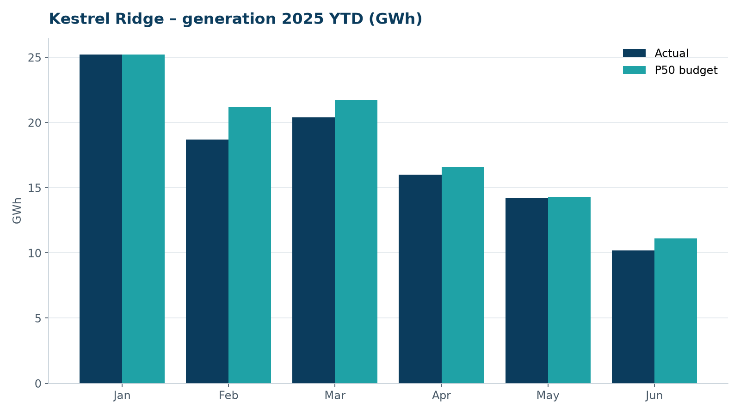
Monthly generation vs. P50 budget, 2025 year to date

3. Availability and downtime
Total turbine downtime attributable to the contractor amounted to 38 turbine-hours for the top events listed below. No grid or force majeure exclusions were claimed this month.
Turbine | Event | Downtime (h)
T-13 | hydraulic oil leak at rotor brake caliper | 11
T-03 | hydraulic oil leak at rotor brake caliper | 9
T-10 | service lift fault – lift locked out, turbine stopped for rescue cover | 9
T-09 | generator slip ring brush wear alarm | 7
T-17 | tower base controller communication loss | 2
Top downtime events of the month (SCADA event log, reviewed with Highline Wind Services).

4. Maintenance
- Annual service: 7 turbines completed this month.
- 11 corrective work orders closed, 2 still open at month end.
- Service lift six-monthly LOLER examinations completed on schedule.

5. Health, safety and environment
Indicator | Month
Hours worked on site (Highline + Weyland) | 5,676
Lost time injuries | 0
First aid cases | 0
Near misses reported | 0
Safety observations | 12
Environmental incidents | 0

No complaints from neighbours were received this month.

6. Outlook
The P50 budget for next month assumes normal seasonal wind; no planned outages beyond routine maintenance.
Prepared by Sara Lindgren (Performance Analyst); reviewed by Ben Okoye (Site Manager) and David Chen (Asset Operations Manager).

